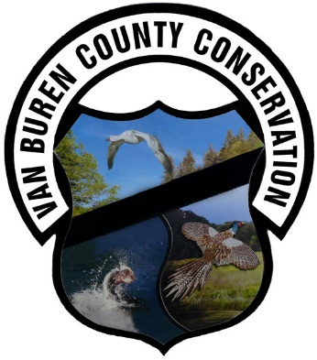
816 Franklin St
Keosauqua, IA 52565
319-293-3589
rdaugherty@vanburencounty.iowa.gov
www.vbcountyconservation.com

Reservation Cancellations/Refunds
- Cancelling a Reservation: Customers may move or cancel their reservation up to 4 or more days prior to arrival. A $10 service fee will be withheld from any refund for a cancellation.
- No Refunds if cancelling 0-3 days prior to arrival
- If the Van Buren County Conservation Board is unable to provide your facility (or similar facility) in operable condition for the date of your event, a full refund will be issued.
- Please call the Van Buren County Conservation Board Office at (319) 293-3589 to cancel your reservation.
- A campsite will be held for you until 12 p.m. the day after your arrival date. If you have not called the park before that time, you will be considered a "no show" and the park will cancel your reservation. If you will miss your first day but plan to arrive later, you must call the camp host 319-293-3532

